

Eircode Web Form & Dynamics 365 Integration Options

Prepared by | Gerry Whelan
Date first issued
Last updated
Version
Document  Classification | Confidential

Document Control

Version History

Version | Date Released | Contributor(s) | Description
0.8 | 09/07/2026 | Gerry Whelan | Initial draft

Document Approval

Approved by | Position | Date

Distribution List

Distributed to | Company | Position | Date

Contents
1. Introduction 2
1.1 Background 2
1.2 Purpose 2
2. Integration Requirements 2
2.1 Description 2
3. Summary of Findings 2
4. Integration Options Examined 3
4.1 Introduction 3
4.2 Option 1A: Xperience by Kentico Third-party Form Integration 3
4.2.1 Approach 3
4.2.2 Evaluation 4
4.3 Option 1B: Xperience by Kentico Customisation 4
4.3.1 Approach 4
4.3.2 Evaluation 5
4.4 Develop a Custom Integration Solution 6
4.4.1 Approach 6
4.4.2 Evaluation 6

References

# | Description | Source
1 | Xperience by Kentico | Xperience by Kentico
2 | Kentico Form submissions | Kentico Form Submissions
3 | Kentico third party integrations | Kentico 3rd party integrations
4 | Kentico Integrate custom code | Kentico Integrate custom code
5 | Entra ID API integration with Dataverse | Entra ID API integration with Dataverse
Table 1 References

Introduction

Background
Project Guardian is tasked to deliver all essential IT services to support the management of national Eircodes. This includes deploying a new public facing web site hosted on An Post Azure and a dedicated contact centre solution running on D365 online.
Along with static content, the Eircode web site will support two public web forms to support user queries. User submitted web form data needs to be routed through to the D365 solution for processing.

Purpose
This document serves as a position paper that presents the options to integrate the two Eircode web forms with the Kentico CMS solution and with the Dynamics 365 solution where form data will be processed.
As a position paper its purpose is to provide a basis that will elicit comments, views, etc. to help align on an agreed approach so that low-level design can proceed.

Integration Requirements

Description
There is a requirement for two web forms which are comprised of standard HTML text boxes, static drop-down lists and submit/cancel buttons.
The web form data needs to be sent to the Eircode D365 online contact centre solution where the data can be actioned.
The web form data consists of name value pairs which need to be send in a structured format using JSON or similar.

Summary of Findings
Three options were assessed for sending Eircode web form submissions to Dynamics 365. The third-party Kentico integration option is not suitable. The Kentico customisation and custom forms application options are both viable.
Option 1A: SendGrid Email. Reject. It is too complex and not designed for direct web form integration with Dynamics 365.
Option 1B: Kentico Custom Extension. Viable. It keeps the forms in Kentico and uses supported customisation, but requires C# component development within the CMS.
Option 2: Stand-alone app. Preferred. A custom forms application gives clearer separation from Kentico and supports a direct, secure API integration with Dynamics 365.
Subject to feedback and agreement, it is proposed to progress using the custom forms application option.

Integration Options Examined

Introduction
This section provides a brief overview of the candidate integration solutions. These are:
- Use Xperience by Kentico Form Integration Support by building the form within the CMS and availing of its integration options. There are two candidates:
  - Use a supported third-party integration
  - Use a customisation within Xperience by Kentico
- Develop a custom solution for the web form and its integration.
These three options are described in detail in the following sub-sections.

Option 1A: Xperience by Kentico Third-party Form Integration

Approach
Third-party integrations as listed in reference 3 are centred around Kentico integration to external systems outside of Kentico CMS. They are NOT specific to external web form integrations.
Of the listed options in reference 3, Twilio SendGrid could be adopted as a means of sending form data within an email. However, it is not designed as a primary integration means but as a method to distribute mail at scale. Its adoption would result in the following high-level architecture.

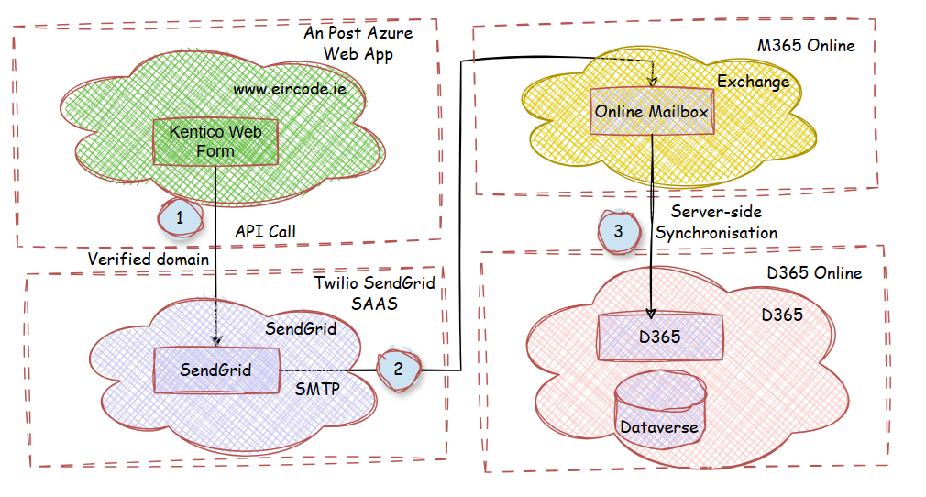
Figure 1 Using Twilio SendGrid for D365 Integration

Evaluation
The solution traverses four clouds with protocol switching between clouds. This is complex and will be difficult to manage and maintain.
As it does not meet best practices for integration, it is proposed to reject this solution.

Option 1B: Xperience by Kentico Customisation

Approach
The other supported option by Kentico is to use a customisation which is to write a C# component (a .Net library project) where custom code can be added (see reference 4).
This would allow a component to be written that:
- Captures the submitted form data
- Perform any transform of the name-values
- Calls a Dynamics Dataverse API submitting the form data.
The following diagram depicts this approach followed by a description.
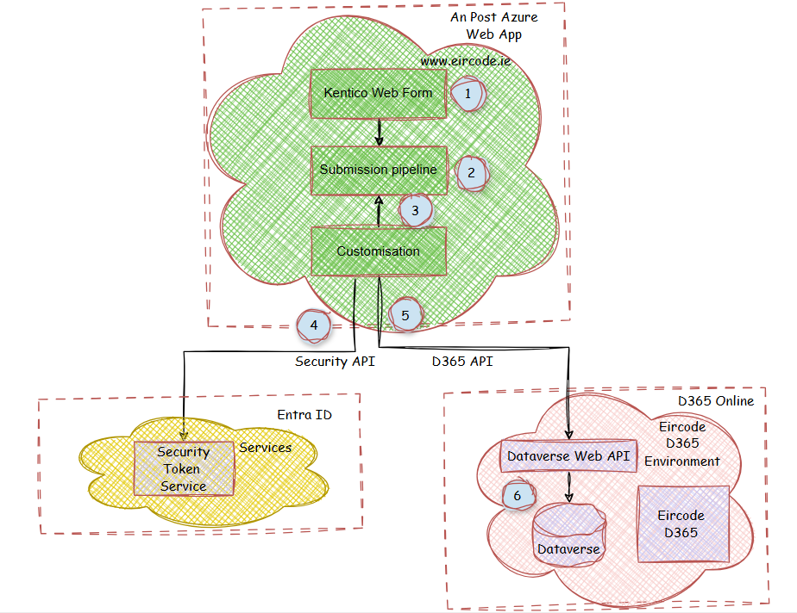
Figure 2 Using a Kentico customisation for Integration
Referring to the diagram numbering.
- A public user submits form data.
- This data internally follows a Kentico flow or pipeline to process the data.
- Within the custom component, a pre-registered hook is registered against this pipeline enabling it to intercept the data within the pipeline.
- After reading the data, the customisation’s code then calls Microsoft Entra ID to fetch a security token before calling D365 Dataverse APIs. (See reference 5.)
- Once the token is acquired, it attaches it to the API and makes the API call to a Dataverse Web API thereby transmitting the data.
- Internal processing by the Dynamics solution then processes the submitted data.

Evaluation
This integration approach improves upon the previous by using standard techniques such as API calls and is supported by Kentico.
It uses best practices in terms of using security tokens (using OAuth authorisation protocol). The customisation runs server-side granting good control over the component. However, the custom code needs to the heavily application security tested given that it runs internal to Kentico runtime.
It will allow a coherent solution in terms of integrated form processing, ability to avail of the Kentico form designers and shared page artefacts like styling, layout, etc.
It will require a non-trivial effort to write the C# customisation, as one needs to be familiar with low-level assembly coding so it is likely to be of medium complexity.
This approach should be considered as a possible candidate.

Develop a Custom Integration Solution

Approach
This approach entails treating the two web forms as a separate application to the Kentico web site. For this approach the two forms would need to be developed as a small web application using a development Framework.
Taking this approach the question is then where to deploy the custom forms application. Potential options are as follows:
- As a separate site
- As an iFrame within Eircode Kentico
- Under the same Eircode Kentico site
The following sub-sections evaluates the overall approach and the three deployment approaches.

Evaluation
Overall, any custom standalone development will result in the page supporting content to be duplicated for each form page including the banners, layouts, stylesheets, navigation, etc. However, given the static nature of the two forms taking them out of direct CMS control and updating them separately would seem acceptable trade-off to an option that provides clean integration.
In terms of the deployment of the custom forms application, as stated there are three options as described below.

Deploy as a Separate Site
This option is feasible particularity as all site access is anonymous and does not need checks on whether users are logged in or not. However, it results in the user navigating to a separate web application, which may complicate session continuity and analytics.

Deploy as an iFrame within Eircode Kentico
You could embed the standalone forms inside a Kentico pages with an iFrame. This approach is technically feasible but is generally not recommended for enterprise applications because it can introduce complications with browser security policies, cross-site cookie restrictions, accessibility, responsive layouts, analytics and long-term maintainability

Under the same Eircode Kentico site
The standalone forms application could be presented under the www.eircode.com domain while being hosted independently of the Kentico application.
Hyperlinks to the forms could be routed to the application while all other site traffic routes to the Kentico CMS application. This is depicted in the following diagram.
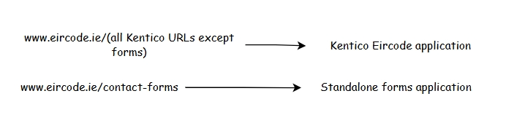
Figure 3 Re-directs between applications
To route the traffic Azure Front Door services could be used to route requests for the forms while routing all remaining requests to the Kentico application.
The following diagram shows a high-level solution of how the solution could be composed. It is followed by a description of the processing sequences.
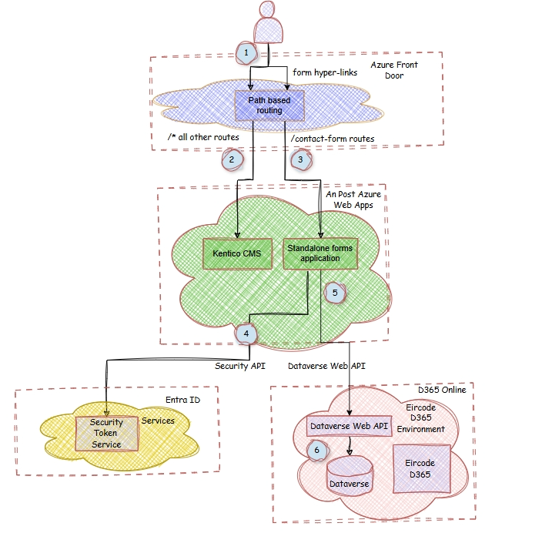
Figure 4 use of a custom app for web forms and integration
The processing steps are as follows:
- The user chooses to select form or non-form content.
- When selecting links to non-form content, the user is routed to the Kentico application,
- When selecting links to the forms, the user is routed to the custom application.
- The custom app accepts the form data and then calls Microsoft Entra ID to fetch a security token before calling D365 Dataverse APIs. (See reference 5.)
- Once the token is acquired, it attaches it to the API and makes the API call to a Dataverse Web API thereby transmitting the data.
- Internal processing by the Dynamics solution then processes the submitted data.

In summary, this option removes the dependency on Kentico enterprise integration capabilities previously mentioned which are not strong.
Overall, this seems like a good option to consider as it provides clean architectural segregation while providing an integrated user experience.

